

Title: DEALING WITH ABUSE AND NEGLECT OF STUDENTS
Adopted: September 16, 2010
Reviewed: September 2, 2013, November 2021
Revised: October 2016, March 2017, February 2021, June 2025
Authority: Child, Youth and Family Services Act
Youth Criminal Justice Act
Related: Procedures HS - 001

POLICY

It is the policy of Bloorview School Authority that each and every student be provided with a safe, nurturing, positive and respectful learning environment.

PRINCIPLES

- The Bloorview School Authority has a legislated duty to prevent, detect, intervene in and report abuse or neglect of any students in accordance with Sec.125 of the Child, Youth and Family Services Act (Appendix A).

- Early identification of child abuse and neglect can occur through disclosure or as the result of reasonable suspicions on the part of Bloorview School Authority employees and volunteers. Reporting disclosures or suspicions may not only prevent future victimization of children, it may also permit both the victim and perpetrator to receive the help they need. Early intervention may ameliorate the long-term effects of abuse and break the ongoing cycle of further victimization and harm.

- For the purpose of this policy, abuse is any form of physical harm, sexual mistreatment, emotional harm, or neglect, which can result in injury or psychological damage. The four categories of abuse of students are described in Procedures HS - #1.

- No student shall experience corporal punishment, physical mistreatment, sexual emotional or verbal abuse by staff. In addition, students shall be protected from violence and harassment, including threats and/or bullying and inappropriate sexual behaviour by other students.

- Bloorview School Authority will educate all of its students about their right to live without fear of physical, sexual, and emotional abuse and neglect and will support disclosure of such abuse.

- Bloorview School Authority will hold all employees and volunteers accountable for the following:

- For any Bloorview School Authority staff or volunteers working directly with a student of any age in their professional capacity (see (b) below), entering into a sexual relationship with that student (or a former student under the age of 18) is a criminal offence

- Professional capacity shall mean working or volunteering at Bloorview School otherwise supervising, counselling, coaching or assisting in extra curricular activities in which the student is participating regardless of which school the student is enrolled.

- Bloorview School Authority will ensure that all prospective employees are screened for records of criminal conviction for sexual offences and offences involving children. All existing staff shall complete an annual offence declaration.

- In compliance with Erin’s Law pupils in the school will be engaged annually, in a developmentally appropriate manner, regarding the topics of child sexual abuse prevention and reporting, including age-appropriate techniques to recognize child sexual abuse and telling a trusted adult. The Authority will educate all of its students about their right to live without fear of physical, sexual, and emotional abuse and neglect and will support disclosure of such abuse.

- In compliance with Erin’s Law, information respecting child sexual abuse prevention and reporting, including information on available counselling and resources for children who are sexually abused, will be made available to all parents and guardians of pupils in the school.

- In compliance with Erin’s Law, information respecting child sexual abuse prevention and reporting, including information on available counselling and resources for children who are sexually abused, will be provided annually to all teachers and other staff in the school.

- The Ministry of Child and Youth Services has produced a brochure available at the following website:

http://www.children.gov.on.ca/htdocs/English/childrensaid/reportingabuse/abuseandneglect.aspx

APPENDIX A

CHILD, YOUTH AND FAMILY SERVICES ACT (ONTARIO)
Duty to Report
Duty to report child in need of protection
125 (1) Despite the provisions of any other Act, if a person, including a person who performs professional or official duties with respect to children, has reasonable grounds to suspect one of the following, the person shall immediately report the suspicion and the information on which it is based to a society:
1. The child has suffered physical harm inflicted by the person having charge of the child or caused by or resulting from that person’s,
i. failure to adequately care for, provide for, supervise or protect the child, or
ii. pattern of neglect in caring for, providing for, supervising or protecting the child.
2. There is a risk that the child is likely to suffer physical harm inflicted by the person having charge of the child or caused by or resulting from that person’s,
i. failure to adequately care for, provide for, supervise or protect the child, or
ii. pattern of neglect in caring for, providing for, supervising or protecting the child.
3. The child has been sexually abused or sexually exploited by the person having charge of the child or by another person where the person having charge of the child knows or should know of the possibility of sexual abuse or sexual exploitation and fails to protect the child.
4. There is a risk that the child is likely to be sexually abused or sexually exploited as described in paragraph 3.
5. The child requires treatment to cure, prevent or alleviate physical harm or suffering and the child’s parent or the person having charge of the child does not provide the treatment or access to the treatment, or, where the child is incapable of consenting to the treatment under the Health Care Consent Act, 1996, refuses or is unavailable or unable to consent to, the treatment on the child’s behalf.
6. The child has suffered emotional harm, demonstrated by serious,
i. anxiety,
ii. depression,
iii. withdrawal,
iv. self-destructive or aggressive behaviour, or
v. delayed development,
and there are reasonable grounds to believe that the emotional harm suffered by the child results from the actions, failure to act or pattern of neglect on the part of the child’s parent or the person having charge of the child.
7. The child has suffered emotional harm of the kind described in subparagraph 6 i, ii, iii, iv or v and the child’s parent or the person having charge of the child does not provide services or treatment or access to services or treatment, or, where the child is incapable of consenting to treatment under the Health Care Consent Act, 1996, refuses or is unavailable or unable to consent to, treatment to remedy or alleviate the harm.
8. There is a risk that the child is likely to suffer emotional harm of the kind described in subparagraph 6 i, ii, iii, iv or v resulting from the actions, failure to act or pattern of neglect on the part of the child’s parent or the person having charge of the child.
9. There is a risk that the child is likely to suffer emotional harm of the kind described in subparagraph 6 i, ii, iii, iv or v and the child’s parent or the person having charge of the child does not provide services or treatment or access to services or treatment, or, where the child is incapable of consenting to treatment under the Health Care Consent Act, 1996, refuses or is unavailable or unable to consent to, treatment to prevent the harm.

10. The child suffers from a mental, emotional or developmental condition that, if not remedied, could seriously impair the child’s development and the child’s parent or the person having charge of the child does not provide the treatment or access to the treatment, or where the child is incapable of consenting to the treatment under the Health Care Consent Act, 1996, refuses or is unavailable or unable to consent to, treatment to remedy or alleviate the condition.
11. The child’s parent has died or is unavailable to exercise custodial rights over the child and has not made adequate provision for the child’s care and custody, or the child is in a residential placement and the parent refuses or is unable or unwilling to resume the child’s care and custody.
Note: On March 1, 2021, the day named by proclamation of the Lieutenant Governor, paragraph 11 of subsection 125 (1) of the Act is amended by striking out “to exercise custodial rights” and substituting “to exercise the rights of custody”. (See: 2020, c. 25, Sched. 1, s. 26 (6))
12. The child is younger than 12 and has killed or seriously injured another person or caused serious damage to another person’s property, services or treatment are necessary to prevent a recurrence and the child’s parent or the person having charge of the child does not provide services or treatment or access to services or treatment, or, where the child is incapable of consenting to treatment under the Health Care Consent Act, 1996, refuses or is unavailable or unable to consent to treatment.
13. The child is younger than 12 and has on more than one occasion injured another person or caused loss or damage to another person’s property, with the encouragement of the person having charge of the child or because of that person’s failure or inability to supervise the child adequately.
Ongoing duty to report
(2) A person who has additional reasonable grounds to suspect one of the matters set out in subsection (1) shall make a further report under subsection (1) even if the person has made previous reports with respect to the same child.
Person must report directly
(3) A person who has a duty to report a matter under subsection (1) or (2) shall make the report directly to the society and shall not rely on any other person to report on the person’s behalf.
Duty to report does not apply to older children
(4) Subsections (1) and (2) do not apply in respect of a child who is 16 or 17, but a person may make a report under subsection (1) or (2) in respect of a child who is 16 or 17 if either a circumstance or condition described in paragraphs 1 to 11 of subsection (1) or a prescribed circumstance or condition exists.
Offence
(5) A person referred to in subsection (6) is guilty of an offence if,
(a) the person contravenes subsection (1) or (2) by not reporting a suspicion; and
(b) the information on which it was based was obtained in the course of the person’s professional or official duties.
Professionals and officials
(6) Subsection (5) applies to every person who performs professional or official duties with respect to children including,
(a) a health care professional, including a physician, nurse, dentist, pharmacist and psychologist;
(b) a teacher, person appointed to a position designated by a board of education as requiring an early childhood educator, school principal, social worker, family counsellor, youth and recreation worker, and operator or employee of a child care centre or home child care agency or provider of licensed child care within the meaning of the Child Care and Early Years Act, 2014;
(c) a religious official;
(d) a mediator and an arbitrator;
(e) a peace officer and a coroner;
(f) a lawyer; and
(g) a service provider and an employee of a service provider.
(7) In clause (6) (b),
“youth and recreation worker” does not include a volunteer.
Director, officer or employee of corporation
(8) A director, officer or employee of a corporation who authorizes, permits or concurs in the commission of an offence under subsection (5) by an employee of the corporation is guilty of an offence.
Penalty
(9) A person convicted of an offence under subsection (5) or (8) is liable to a fine of not more than $5,000.
Section overrides privilege; protection from liability
(10) This section applies although the information reported may be confidential or privileged, and no action for making the report shall be instituted against a person who acts in accordance with this section unless the person acts maliciously or without reasonable grounds for the suspicion.
Solicitor-client privilege
(11) Nothing in this section abrogates any privilege that may exist between a lawyer and the lawyer’s client.
Conflict
(12) This section prevails despite anything in the Personal Health Information Protection Act, 2004.


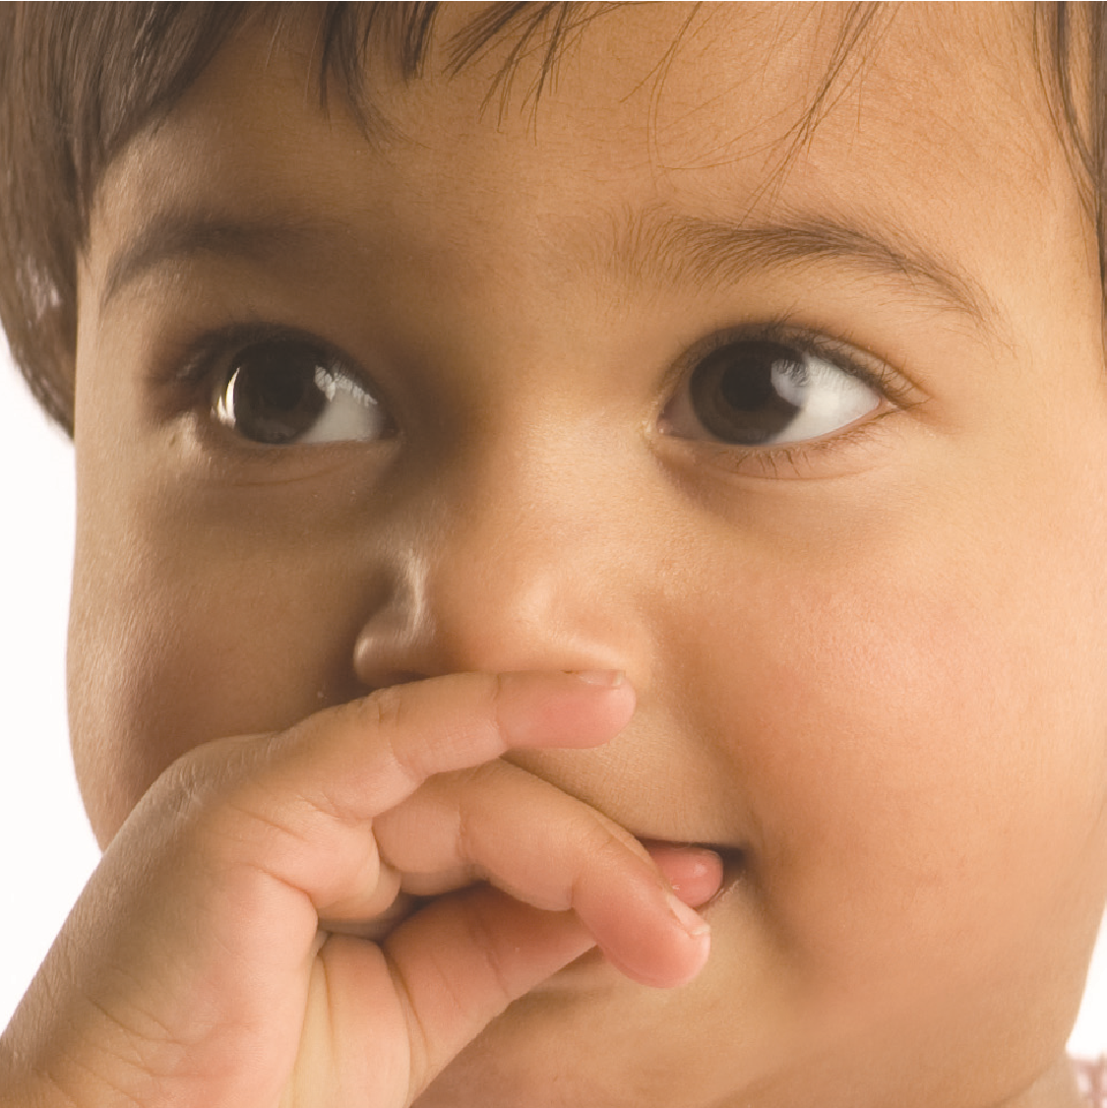

Reporting Child Abuse and Neglect: It’s Your Duty
Your responsibilities under the Child, Youth and Family
Services Act, 2017

The Child, Youth and Family Services Act, 2017 (CYFSA) recognizes that each of us has a responsibility for the welfare of children.

Introduction
We all share a responsibility to protect children from harm. This includes situations where children are abused or neglected in their own homes. Ontario’s Child, Youth and Family Services Act, 2017 (CYFSA) provides for protection for these children.
Section 125 of the CYFSA states that the public, including professionals who work with children, must promptly report any suspicions that a child is or may be in need of protection to a children’s aid society (society). The CYFSA defines the phrase “child in need of protection” and explains what must be reported to a society. It includes physical, sexual and emotional abuse, neglect, and risk of harm.
This brochure explains the “duty to report” section of the CYFSA and answers common questions about your reporting responsibilities. It also includes relevant portions of Section 125 for your reference. It does not provide specific legal advice. Please consult a lawyer or a society about any specific situation.
Who is a “child in need of protection”?
The CYFSA defines a child in need of protection and clearly specifies how you can identify these children in Section 125 (1). (See pages 8-11). [CYFSA s.125 (1)] This includes a child who is or may be suffering from abuse or neglect.
Who is responsible for reporting a child in need of protection?
Anyone who has reasonable grounds to suspect that a child is or may be in need of protection must promptly report the suspicion and the information upon which it is based to a society. Section 125 (1) describes the specific circumstances that must be reported (See pages 8-11). [CYFSA s.125 (1)]
What are “reasonable grounds” to suspect child abuse or neglect?
It is not necessary for you to be certain a child is or may be in need of protection to make a report to a society. “Reasonable grounds” refers to the information that an average person, using normal and honest judgment, would need in order to decide to report.
What is the age of the children to whom the “duty to report” applies?
The duty to report applies to any child who is, or appears to be, under the age of 16 years.
On January 1, 2018, Ontario raised the age of protection from 16 to 18. A professional, or member of the public, who is concerned that a 16-or 17-year-old is or may be in need of protection may, but is not required to, make a report to a society and the society is required to assess the reported information. [CYFSA, s. 125(4)]
2 3
What does an “ongoing duty to report” child abuse or neglect mean?
Even if you know a report has already been made about a child who is under 16, you must make a further report to the society if there are additional reasonable grounds to suspect that the child is or may be in need of protection. [CYFSA s.125 (2)]
Can I rely on someone else to report?
No. You have to report directly to a society. You must not rely on anyone else to report on your behalf. [CYFSA s.125 (3)]
Do professionals and officials have any special responsibilities to report?
Professionals and officials have the same duty as the rest of the public to report their suspicion that a child is or may be in need of protection. However, the CYFSA recognizes that people working closely with children have a special awareness of the signs of child abuse and neglect, and a particular responsibility to report their suspicions. Any professional or official who fails to report a suspicion is liable on conviction to a fine of up to $5,000, if they obtained the information in the course of their professional or official duties. Reporting is not mandatory in the case of 16- and 17- year-olds and the offence/penalty provisions don’t apply. [CYFSA s.125 (5), (8), (9)]
Who does the CYFSA consider a
person who performs professional or official duties?
· health care professionals, including physicians, nurses, dentists, pharmacists and psychologists
· teachers and school principals
· social workers and family counsellors
· religious officials
· operators or employees of a child care centre or home child care agency
· youth and recreation workers (not volunteers)
· peace officers and coroners
· child and youth service providers and employees of these service providers
· any other person who performs professional or official duties with respect to a child
In addition to the professionals and officials outlined above, directors, officers or employees of a corporation also have a legislated duty to report if they have knowledge that a child who is under 16 is or may be in need of protection. [CYFSA s. 125 (8)]
These are examples only. If you are unsure whether you fall into any of these categories, ask your local society, or the legal counsel for your professional association, regulatory body, or organization. [CYFSA s.125 (6)]
4 5
What about professional confidentiality?
A professional must report that a child is or may be in need of protection, even when the information is otherwise confidential or privileged. This duty overrides any other provincial statutes, including the Personal Health Information Protection Act, 2004, and specifically overrides any provisions that would otherwise prohibit someone from making a disclosure. Only lawyers may not divulge “privileged” information about their clients. [CYFSA s.125 (10), (11)]
Will I be protected from liability if I make a report?
The CYFSA provides that no action for making the report will be instituted against a person who makes a report unless the person acts maliciously or without reasonable grounds for the suspicion. [CYFSA s.125 (10)]
What happens when I call a society?
The society will investigate the information. The society has the responsibility and authority to investigate allegations and to protect children. The society may involve the police and other community agencies. All societies provide emergency service 24 hours a day, seven days a week.
Consistent with the best interests, protection and well-being of children, services from a society will take the following into consideration:
· respect for a child’s need for continuity of care and for stable relationships within a family and cultural environment,
· the physical, emotional, spiritual, mental and developmental needs and differences among children,
· a child’s race, ancestry, place of origin, colour, ethnic origin, citizenship, family diversity, disability, creed, sex, sexual orientation, gender identity and gender expression,
· a child’s cultural and linguistic needs,
· the goal of achieving permanent plans for children in accordance with their best interests, and
· the participation of a child, the child’s parents and relatives and the members of the child’s extended family and community, where appropriate. [CYFSA s.1 (2)]
How do I contact a society or get more information?
You can find your local society in your local telephone listings or, where available, by dialing 411. In some communities, the society is known as “family and children’s services” or “child and family services”.
You can also find information about all of Ontario’s societies at www.oacas.org, the web site of the Ontario Association of Children’s Aid Societies.
Anyone who has a reasonable suspicion that a child is or may be in need of protection must contact a society immediately.
If you think the matter is urgent and you cannot reach the society, call your local police.
6 7
Section 125 (1) of the Child, Youth and Family Services Act, 2017
Despite the provisions of any other Act, if a person, including a person who performs professional or official duties with respect to children, has reasonable grounds to suspect one of the following, the person shall immediately report the suspicion and the information on which it is based to a society:
- The child has suffered physical harm inflicted by the person having charge of the child or caused by or resulting from that person’s,
  - failure to adequately care for, provide for, supervise or protect the child, or
  - p attern of neglect in caring for, providing for, supervising or protecting the child.
- There is a risk that the child is likely to suffer physical harm inflicted by the person having charge of the child or caused by or resulting from that person’s,
  - failure to adequately care for, provide for, supervise or protect the child, or
  - p attern of neglect in caring for, providing for, supervising or protecting the child.
- The child has been sexually abused or sexually exploited by the person having charge of the child or by another person where the person having charge of the child knows or should know of the possibility of sexual abuse or sexual exploitation and fails to protect the child.
8
- There is a risk that the child is likely to be sexually abused or sexually exploited as described in paragraph 3.
- The child requires treatment to cure, prevent or alleviate physical harm or suffering and the child’s parent or the person having charge of the child does not provide the treatment or access to the treatment, or, where the child is incapable of consenting to the treatment under the Health Care Consent Act, 1996, refuses or is unavailable or unable to consent to, the treatment on the child’s behalf.
- The child has suffered emotional harm, demonstrated by serious,
  - anxiety ii. depression iii. withdrawal
iv. self-destructive or aggressive behaviour, or v. delayed development, and there are reasonable grounds to believe that the emotional harm suffered by the child results from the actions, failure to act or pattern of neglect on the part of the child’s parent or the person having charge of the child.
- The child has suffered emotional harm of the kind described in subparagraph 6 i, ii, iii, iv or v and the child’s parent or the person having charge of the child does not provide services or treatment or access to services or treatment, or, where the child is incapable of consenting to treatment under the Health Care Consent Act, 1996, refuses or is unavailable or unable to consent to, treatment to remedy or alleviate the harm.
9
- There is a risk that the child is likely to suffer emotional harm of the kind described in subparagraph 6 i, ii, iii, iv or v resulting from the actions, failure to act or pattern of neglect on the part of the child’s parent or the person having charge of the child.
- There is a risk that the child is likely to suffer emotional harm of the kind described in subparagraph 6 i, ii, iii, iv or v and the child’s parent or the person having charge of the child does not provide services or treatment or access to services or treatment, or, where the child is incapable of consenting to treatment under the Health Care Consent Act, 1996, refuses or is unavailable or unable to consent to, treatment to prevent the harm.
- T he child suffers from a mental, emotional or developmental condition that, if not remedied, could seriously impair the child’s development and the child’s parent or the person having charge of the child does not provide the treatment or access to the treatment, or where the child is incapable of consenting to the treatment under the Health Care Consent Act, 1996, refuses or is unavailable or unable to consent to, treatment to remedy or alleviate the condition.
- T he child’s parent has died or is unavailable to exercise custodial rights over the child and has not made adequate provision for the child’s care and custody, or the child is in a residential placement and the parent refuses or is unable or unwilling to resume the child’s care and custody.
10
- The child is younger than 12 and has killed or seriously injured another person or caused serious damage to another person’s property, services or treatment are necessary to prevent a recurrence and the child’s parent or the person having charge of the child does not provide services or treatment or access to services or treatment, or, where the child is incapable of consenting to treatment under the Health Care Consent Act, 1996, refuses or is unavailable or unable to consent to treatment.
- The child is younger than 12 and has on more than one occasion injured another person or caused loss or damage to another person’s property, with the encouragement of the person having charge of the child or because of that person’s failure or inability to supervise the child adequately.
If someone has reasonable grounds to suspect that a child under 16 is or may be in need of protection, they must make a report directly to a society. A report may be made regarding 16- and 17- year-olds if you are concerned that they are, or may be, in need of protection.11
To order by phone:
1-800-668-9938
TTY: 1-800-268-7095

Or visit
www.serviceontario.ca/publications Publication #026517
Learn more: www.ontario.ca/children
Ce document est également disponible en français
ISBN 978-1-4868-1810-5 (Print)
ISBN 978-1-4868-1811-2 (HTML)
ISBN 978-1-4868-1812-9 (PDF)
Mar/2018 / Reprint © Queen’s Printer for Ontario

